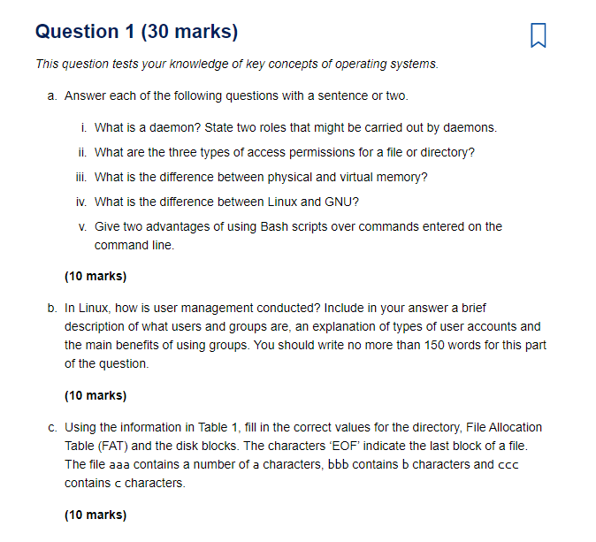
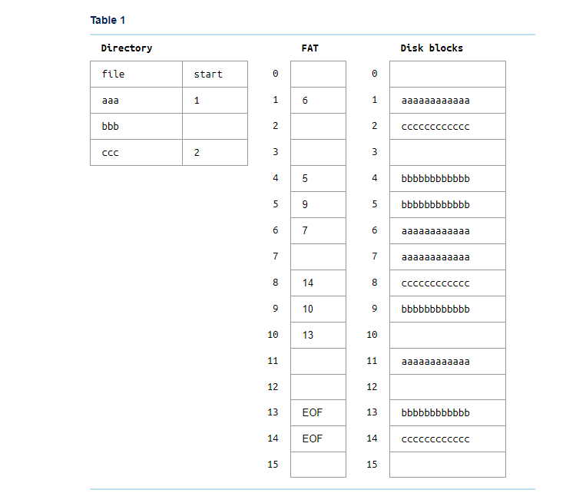

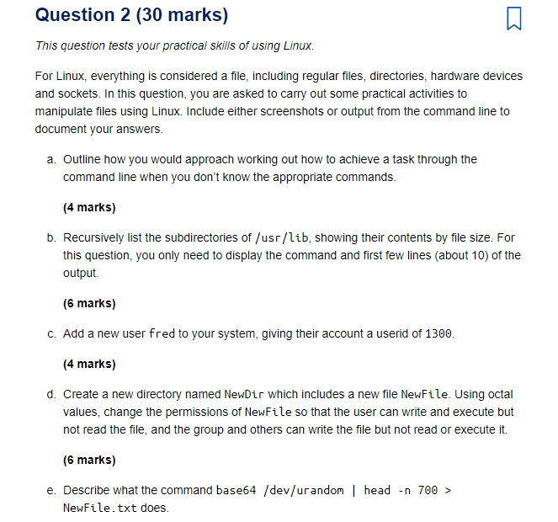
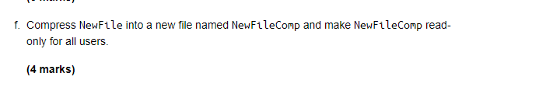

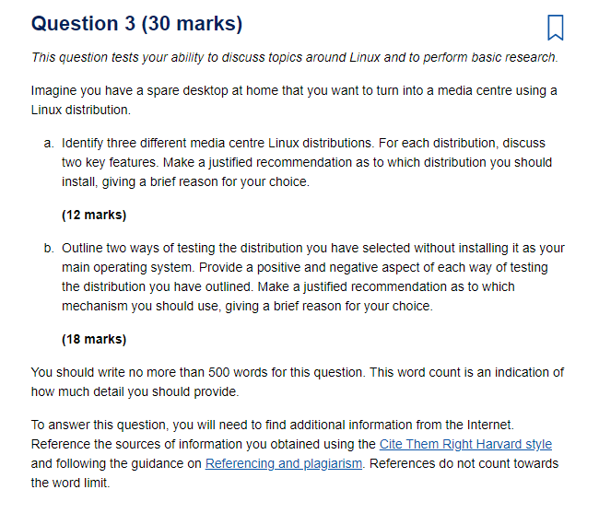

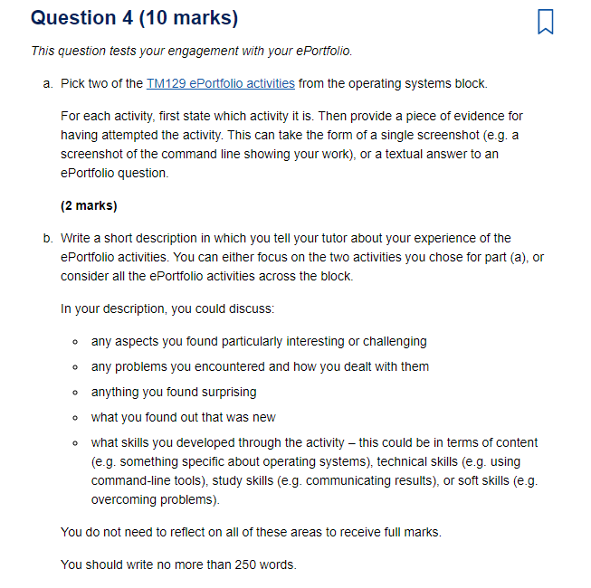

Part 1 Short-answer questions (15 marks)
- a.Briefly describe the ping and traceroute commands. If you were experiencing difficulties in connecting to a remote service, how might you use the ping command to check whether the problem is within your local network?
Write no more than 150 words.
(5 marks)
- b.Drawing on what you have learnt from the robotics block, do you think the development of advanced robots and AI algorithms have had a positive or negative impact on human society? Consider both the positive and negative impacts, and come to a justified conclusion.
Write no more than 150 words.
(5 marks)
- c.The table below shows a list of processes for a processor, the order in which they have arrived at the processor, and how many cycles of the processor each process will take to complete.
Task ID | Arrival order | Cycles to completion
Process A | 1 | 12000
Process B | 2 | 6000
Process C | 3 | 2000
- Using a first-come first-served scheduler, how many cycles will it take until Process B is completed?
Using a round-robin scheduler with each process getting 2000 cycles in turn, how many cycles will it take until Process B is completed?
Suggest a kind of scheduler to use when an operating system requires a lot of input/output from a user. Give a brief justification for your answer.
Write no more than 100 words.
(5 marks)

Part 2 Block questions
Answer two questions chosen from A, B and C. If you submit more than two, then only the first two will be marked.
Each question includes guidelines on how many words to write. You will lose marks if you exceed the word limits. The majority of the material you provide should be in your own words. If you quote from or refer to material from other sources, provide full references. See the guide at Referencing and plagiarism. References are excluded from the word limits.

Question A (30 marks)
This question involves you building and configuring a small office network in Packet Tracer. Download the EMA Packet Tracer file EMA_Qa_Base_Network_20J.pkt from the Assessment page of the TM129 website.
Open the Packet Tracer file and immediately save the file as <PI>_TM129_20J_EMA_Qa.pkt where <PI> is your Open University Personal Identifier (in the form A1234567). You can find your PI on your StudentHome page. Your file should now be called something like A1234567_TM129_20J_EMA_Qa.pkt.
You do not need to submit your Packet Tracer file. All of the questions require you to provide the answers in your EMA answer document. Please state the version of Packet Tracer used.

(a) Planning the network addressing scheme (14 marks)
Before cabling and connecting your network devices, you will need to plan your addressing scheme to make sure you have enough addresses available for each device on the network.
On the wireless router click on the GUI tab. Under the Setup tab, locate the DHCP settings for the router. These have been preconfigured so do not change them.
- i.Populate the following table with the addressing information you have located.

Table 1 Router
Router IP address | Subnet mask | Max users | First user address | Last user address | Lease time
- ii.From the router IP address and the subnet mask, calculate the network address, showing your working. Also state the broadcast address, the first usable host address and the last usable host address, explaining how you arrived at these numbers.
Hint: you will find the logical AND will help you calculate these addresses.
- iii.Use the table below to plan the addressing for each device. To do this you will need the following information.
  - The wireless router address and subnet mask are preconfigured.
  - The web server will use the last available address of the range.
  - The printer will use the second-to-last available address of the range.
  - PC0 to PC2 will use the first three available addresses of the range.
  - The laptop and the smartphone will be configured for DHCP later, so these addresses will come from the pool.

Table 2 Addressing plan
Device | Interface | IP address | Subnet mask | Default gateway
Wireless router | LAN
Web server | Fast Ethernet 0
Printer | Fast Ethernet 0
PC0 | Fast Ethernet 0
PC1 | Fast Ethernet 0
PC2 | Fast Ethernet 0
Laptop | Wireless 0
Smartphone | Wireless 0

(b) Building and addressing your network (5 marks)
- i.Make the physical connections for each network device with the following requirements.
  - Connect PC0 to the Ethernet 2 port on the WRT300N wireless router using the correct cable.
  - Connect the switch using the FastEthernet0/1 port to the Ethernet 1 port on the WRT300N wireless router using the correct cable.
  - Connect the web server to the FastEthernet0/2 port on the switch using the correct cable.
  - Connect the printer to the FastEthernet0/3 port on the switch using the correct cable.
  - Connect PC1 to the switch via FastEthernet0/4 and connect PC2 to FastEthernet0/5.
PC0 is connected to the switch using a console cable; you should not change this connection.
- ii.Enable DHCP on the laptop and the smartphone. What are the IP address, subnet mask and default gateway issued to these devices?
- iii.Configure the IP address settings on the web server, printer, PC0, PC1 and PC2. This should be done based on your addressing plan in Table 2.
- iv.Add the DNS address of 192.168.0.254 to PC0, PC1 and PC2.
Use the ‘Place Note’ function in Packet Tracer to add a label to each device showing the IP settings for that device. Include a screenshot with these labels showing the cabling and IP settings for each device you have configured.

(c) Testing for connectivity (3 marks)
- i.Test the network layer connectivity by issuing a ping command from PC0 to the printer, PC2 and the laptop. Include a brief description of what you have done and include one screenshot as evidence.
- ii.Test application layer connectivity by opening the browser on PC0 to access http://webserver.com. Include a brief description of what you have done and include one screenshot as evidence.

(d) Switch setup (8 marks)
Here you will configure basic security features on the switch. Working from the switch CLI from PC0 you will need to do the following:
- configure the host name SOHO-Switch
- configure a login banner MOTD that reads, ‘Unauthorised access is strictly prohibited.’
- configure the console password to tm12920j
- configure enable password to tm129.
For each of these configuration activities, identify the purpose of each configuration, give a brief explanation of what you have done and provide a screenshot demonstrating each configuration change.

Question B (30 marks)
As robots and AI algorithms continue to improve, they will be increasingly used in many domains. In a 2019 report, the World Economic Forum has noted that this will include education, including at university level.
Write a short article about the current state of robotics used in the context of education. This can include education at any age, from nursery school children to university, or informal learning outside of the classroom. You may include robots that are commercially available or that exist as prototypes. You may also wish to comment on any market failures and explain why such services may have failed.
Write no more than 700 words.
Your article should be based on the following plan.
- Give three examples of robots designed for use in education. For each example, you should outline the tasks the robot can complete.
(3 marks)
- Give a brief description of each robot, referring to concepts and topics discussed in the robotics block. You should cover four elements for each robot, such as the level of autonomy, the sensors used, the actuators used, how the robot is powered or how ‘intelligent’ the robot is.
(12 marks)
- Briefly discuss how a student is intended to interact with each robot. Among these robots, highlight one form of interaction you feel would benefit the learner, and one you feel would be a shortcoming.
(5 marks)
- Briefly discuss any social, legal, economic or ethical issues associated with using robots in the context of education.
(4 marks)
Give references to the sources of your information. Use the Cite Them Right Harvard style.
(3 marks)
Marks will also be allocated for the overall quality of your writing in this question (including clarity, structure, spelling, punctuation and grammar).
(3 marks)

Question C (30 marks)
Before Linux existed, an operating system named MINIX was developed by Andrew Tanenbaum. Although over 30 years old, the MINIX operating system is still running.
Read the following article (and watch the associated video) by Prof Tanenbaum that discuss this project: Lessons Learned from 30 Years of MINIX.
Using this article, write a report on MINIX. Write no more than 700 words.
You may have to find and use additional source material to answer the question; if you do so, then you must provide references.
In your report, you should do the following.
- Explain what MINIX was designed for. Discuss the relationship between MINIX and Linux.
(3 marks)
- State four lessons learnt regarding the development of MINIX that are identified in the article. For each lesson, discuss its relevance to the development of operating systems today.
(12 marks)
- Describe what a microkernel is and how it differs from a monolithic kernel. Discuss one advantage and one disadvantage of using a microkernel.
(6 marks)
- Discuss whether you believe the MINIX project was a success. Justify your answer.
(4 marks)
- Provide a reference for the article provided in the question, and for any other sources you have used. Use the Cite Them Right Harvard style.
(2 marks)
Marks will also be allocated for the overall quality of your writing in this question (including clarity, structure, spelling, punctuation and grammar).
(3 marks)

Part 3 ePortfolio and study skills (25 marks)
In all three blocks you will have carried out several ePortfolio activities, indicated with the ePortfolio icon (). You were asked to provide evidence of your work for the ePortfolio activities, together with comments on the knowledge and skills you have demonstrated in each of the TMAs. In this part of the EMA, you will further reflect on these ePortfolio activities, and on your experience of TM129 as a whole.
Some of these questions are based around different parts of the FutureYou tool.
- a.Write a short description about your experience of the ePortfolio activities. You should focus on all of the ePortfolio activities across the module.
In your description, you could discuss:
  - any aspects you found particularly interesting or challenging
  - any issues or problems you encountered and how you dealt with them
  - anything you found surprising
  - what you found out that was new
  - what skills you developed through the activity; this could be in terms of content (e.g. something specific about robotics), technical skills (e.g. programming), study skills (e.g. communicating results), or soft skills (e.g. overcoming problems).
You do not need to reflect on all of these areas to receive full marks. Use the feedback from your TMAs when answering this question.
Write no more than 300 words.
(10 marks)
- b.Based on Activities 3 and 4 of the FutureYou tool.
In each of the TMAs, you provided evidence of having completed two ePortfolio activities, giving a total of six activities across the module.
Using a scale of 1–5 (with 5 meaning highly developed and 1 meaning not developed), rate your current skills and attributes against the following statements as demonstrated across all six activities.
  - Able to find, and critically analyse relevant information to solve a problem.
  - Logically analyse and deconstruct a problem and look for creative solutions.
  - Make decisions in a methodical/systematic way recognising potential impacts.
  - Generate and evaluate a range of problem-solving strategies.
  - Resolve differences of opinion through perspective taking and recognising all variables affecting an issue.
  - Recognise and utilise support systems and work with colleagues in problem solving.
What do these ratings tell you about your existing abilities? Are there any surprises or does it confirm your expectations? Which areas would you like to further improve?
Write no more than 200 words.
(8 marks)
- c.Based on Activity 5 and the reviewing and evaluating section of the FutureYou tool.
Write a short vision statement of up to 200 words in which you describe yourself in five years’ time. Your statement should relate to your career and/or study aims rather than personal objectives, so for example you may be aiming towards a promotion, a job change, doing voluntary work in the community, or completing a postgraduate degree. The statement should include your study goals, for example whether you will have finished or nearly finished your OU qualification by then or developed other specific skills.
Discuss how studying TM129 has helped you towards your career and/or study aims. What skills do you think you need to further develop to help you achieve your career and/or study aims? Write no more than 200 words.

Example vision statements

Statement 1
In five years’ time I imagine myself working in a large IT company. Having completed my OU computing and IT qualification, I’m now a project manager with responsibility for a small team of software developers, and I have autonomy about how my budget is spent. Although there is pressure to meet deadlines, I enjoy the challenges of my role. I have some flexibility with my working hours – for example, I can work from home when necessary. I find the work rewarding, and my team is producing high-quality work.
I feel TM129 has helped me develop study skills that will be important for the remaining modules in my degree, particularly practising programming. Learning how to do independent research, and assess external material, has also been useful, and something which will also help in my future career. I struggled with aspects of the networking course, and as this is an important part of the degree programme, I either need to select other modules to focus on, or work particularly hard at improving my understanding of networking.
(174 words)

Statement 2
In five years’ time I imagine myself volunteering for a local community centre two days per week, supporting small businesses and individuals with their IT requirements. I feel confident in using a range of IT equipment and applications, and in trying out new products. I enjoy helping others to understand and use these, so I am considering offering some training courses at the community centre. I am still working towards my OU qualification and am studying an OU level 3 module on user experience and interaction design.
A lot of the activities I undertake as a volunteer involve helping small organisations work out how to network their machines together. As I had no formal training and little practical experience of networking before studying TM129, that part of the module has been very helpful to me. However, I have struggled with being able to communicate my thoughts clearly, and the long-answer essay questions in TM129 have highlighted this. As this will be needed in many other modules, this is a clear area I need to develop.
(175 words)
- (7 marks)

